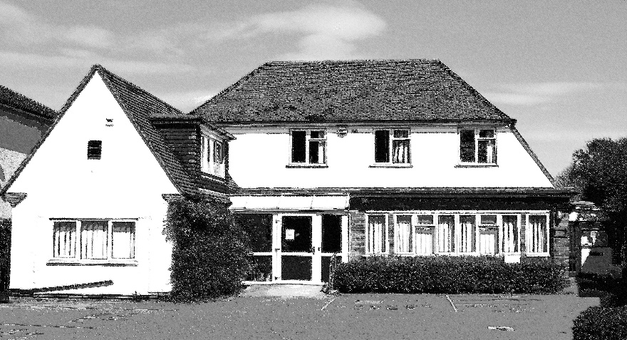

**PLAS MEDDYG SURGERY Patient Participation Group Report**

**March 2013**

**Surgery Opening Times**

Plas Meddyg Surgery telephone line is open Monday – Friday 08:00-18.30.

The Practice provides extended hours Wednesday evening 18:30-20:00 and Thursday morning 07:00

Below the table shows the surgery times:

|  |  |  |
| --- | --- | --- |
|  | **Morning** | **Afternoon** |
| **Monday** | 8.30-11.30am | 3.00-6.30pm |
| **Tuesday** | 8.30-11.30am | 3.00-6.30pm |
| **Wednesday** | 8.30-11.30am | 3.00-8.00pm |
| **Thursday** | 7.00-11.30am | 3.00-6.00pm |
| **Friday** | 8.30-11.30am | 3.00-6.30pm |

**Development of the PPG Group**

Plas Meddyg Surgery Patient Participation Group (PPG) has been meeting since January 2012. The group hold face to face meetings and have held eight meetings since then. Our group consists of 10 members and are represented by 2 male and 8 female patients. All but one member, who is Asian are White British.

**Age profile of the group**:

6 x 35-54 years

2 x 55-64 years

4 x 65+

**The practice population as of March 2013**:

0-16 years 20%

17-34 years 19%

35-54 years 29%

55-64 years 10%

65-74 years 10%

75+ years 12%

Male – 47%

Female- 53%

**Ethnicity**

British or mixed British - 83.31%

Other White background - 4.67%

Irish - 1.25%

White & Black Caribbean – 0.35%

White & Asian – 0.61%

Indian – 1.96%

African – 1.49%

Chinese – 0.72%

Other – 3.4**%**

We feel our PPG is a good representation of our registered patients. However we will review this regularly. We have displayed on the PPG notice board a poster asking for new members either to join the group or sign up to our virtual PPG. There is also a comment box asking for patients views and this is opened at the beginning of each meeting and discussed and responded to by the group.

**Agreeing Priority Areas**

We discussed the action plan from last year and the only outstanding item not actioned was the 0844 telephone number. The practice has been in discussion with their current telephone supplier to revert back to a local number however the contract has 18 months still to run and to cancel the contract would not be viable.

We discussed this year’s survey at our July 2012 PPG meeting. The PPG members wanted this time to additionally ask questions on obtaining appointments. The survey was then drafted and emailed to all members. With comments and amendments the final version was taken to the September 2012 meeting for approval.

**Obtaining the views of patients**

The survey was given to patients during the flu clinics in October 2012 upon their arrival and they were asked if they would be happy to participate in the survey. We felt this would be a good way to get a cross section of patients. Also we had help from the PPG members at these clinic’s who explained the reason for the survey and were able to give help to the patients who needed it. 100 surveys were handed out but only 70 were completed. The results were input onto an Excel spreadsheet. The results were emailed to all PPG members in advance of our meeting to be held in March 2013. So they would be able to analyse and discuss this and the action plan forward.

**Discussion of Action Plan**

PPG met on 7th March 2013 during this meeting we discussed the results from the survey. Everyone felt these results were very positive with patients expressing a high level of satisfaction.

We discussed the least positive comment being 0844 telephone number. The survey results showed 46% of patients did not know how to make a complaint or suggestion. Also the PPG members had received comments from patients regarding the running of the 2012 flu clinics.

The discussion of the results was concluded and it was agreed that an action plan would be drawn up. The action plan and report would be emailed to all PPG members for agreement and would then be published.

**Results from survey**

Age group

Gender

Which of these describes you?

How long have you been with the surgery?

When was the last time you visited the surgery?

Do you have any disabilities?

What is your ethnic group

How would you describe your experience when you last visited the surgery

How would  you describe your experience of getting an appointment

How did you find the reception area

How would you describe the reception area

How did you find getting through via the telephone

Were you able to get an appointment on the same day or in next two working days

If you weren't able to be seen what was the reason

The doctor/nurse took an interest

My problem or treatment was explained i full

I understood what I was being told

I had input in the treatment I would be receiving

The cleanliness of the clinical room was of a high standard

Do you know how to make a complaint, suggestion or comment

How would you like to receive information from the practice

Would you like to join our virtual PPG

|  |  |  |  |  |  |  |  |  |  |  |  |  |  |  |
| --- | --- | --- | --- | --- | --- | --- | --- | --- | --- | --- | --- | --- | --- | --- |
| **Please tell us below any other ways that services could be improved at the surgery** | | | | | | | | | | | | | | |
|  |  |  |  |  |  |  |  |  |  |  |  |  |  |  |
| Turn off annoying hip-hop music | | | | | | | | | | | | | | |
| Stop using an 0845 contact number | | | | | | | | | | | | | | |
| I have not got time to join virtual PPG, otherwise I would | | | | | | | | | | | | | | |
| None, very happy with the surgery | | | | | | | | | | | | | | |
| Would like a local 0208 number instead of 0844 which costs extra on my phone bill | | | | | | | | | | | | | | |
| Can't see any improvement needed, must be the best in the area | | | | | | | | | | | | | | |
| This is the best surgery I have ever belonged to (smiley face) | | | | | | | | | | | | | | |
| Services are fine | | | | | | | | | | | | | | |
| No, it is run wonderfully thank you | | | | | | | | | | | | | | |
| Could not be improved upon | | | | | | | | | | | | | | |
| OK as it is | | | | | | | | | | | | | | |
| Saturday surgery | | | | | | | | | | | | | | |
| Inform the patients by approx how much the doctor is 'running behind' | | | | | | | | | | | | | | |
| None, excellent service at all times | | | | | | | | | | | | | | |
| Change the telephone system | | | | | | | | | | | | | | |
| Nothing to say except compliments | | | | | | | | | | | | | | |
| The telephone service can be very repetitive and irritating, when the receptionist answer that's fine | | | | | | | | | | | | | | |
| More parking! | | | | | | | | | | | | | | |
| Very good already, cannot think of improvements | | | | | | | | | | | | | | |
| Happy how it is | | | | | | | | | | | | | | |
| The surgery is amazing. The reception team and doctors are the best I've ever seen. I am so impressed with the | | | | | | | | | | | | | | |
| service I honestly cannot think of anything to improve. |  | |  |  |  |  |  |  |  |  |  |  |  |  |
|  |  |  |  |  |  |  |  |  |  |  |  |  |  |  |

**Action Plan 2013**

|  |  |  |  |
| --- | --- | --- | --- |
| **Area of change** | **Recommendation** | **Practice Lead** | **Comments** |
| 0844 telephone number | Surgery aware the needs for 0844 to revert to a geographical number but at present we are unable to break contract as to costly but will revert to a local number in February 2014 when contract ends. | Practice Manager | Feb 2014 |
| Access | Installed a patient check-in screen to enable patients to check-in themselves enabling the receptionist to answer the phones promptly and there is also a scrolling message display which allows the surgery to inform patients when the doctors are running late and to notify patients with up to date information. | Practice Manager | Installed Jan 2013 |
| Communication | Display a poster on how patients can make a complaint. | Practice Manager | Notice board update March 2013 |
| Communication – Choose Well | To hold a ‘Choose Well’ event with the help of a staff member from the CCG to help bring awareness to patients of the local services available and how to use the most appropriate service. | Practice Manager & CCG | April 2013 |
| Organisation – Flu Clinic’s | It was felt the 2012 flu clinics was a bit disorganised. PPG members volunteered to help with the 2013 clinics. | Receptionist’s & PPG | October 2013 |

**Publication of Report**

A copy of the annual report has been circulated to all PPG members. A copy will be placed on the PPG notice board and published on our surgery website [www.plasmeddygsurgery.com](http://www.plasmeddygsurgery.com).

**12th March 2013**